NAVIGATION FLOW
What
The Navigation Flow defines the steps an end user follows to access the ServiceNow Service Portal, locate the Network Requests service, submit the required information, and receive confirmation of the newly created request.
The flow provides a simple user journey from request initiation → form submission → request generation → notification.
Why
A clearly defined navigation flow helps users access the service without requiring knowledge of the underlying ServiceNow configuration.
The process is designed to:
- Provide a simple entry point for network requests.
- Reduce navigation complexity.
- Ensure users submit requests through the standardized Service Catalog.
- Generate a trackable request number.
- Provide confirmation through email notifications.
How
Step 1 – Access the ServiceNow Instance
Log in to the organization's ServiceNow Personal Developer Instance (PDI) or designated ServiceNow environment.
Use the instance URL provided for the project.
Documentation note: Replace the actual instance domain with <ServiceNow PDI URL> in the final report.
Step 2 – Access the Service Portal
Open the Service Portal by adding the /sp prefix/path to the ServiceNow instance URL.
Example:
<ServiceNow PDI URL>/sp
The Service Portal provides the user-facing interface for accessing available services.
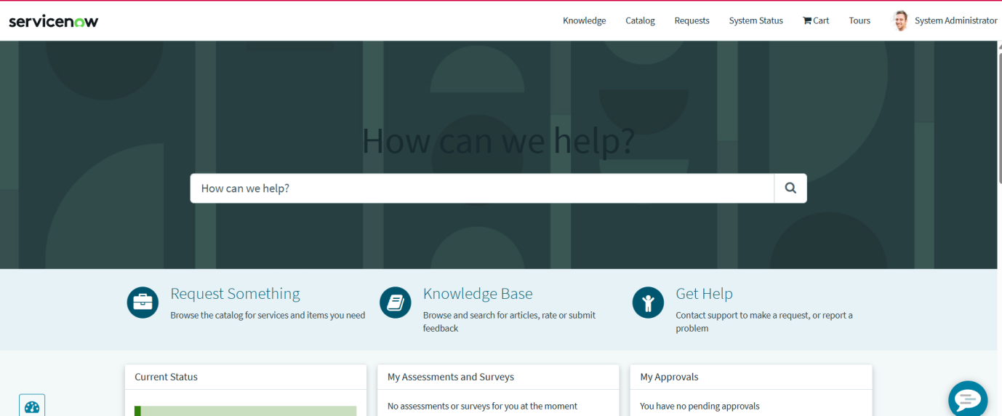

Step 3 – Search for Network Requests
- Locate the Service Portal search option.
- Search for:
Network Requests
- Select the appropriate network request service/catalog item from the search results.
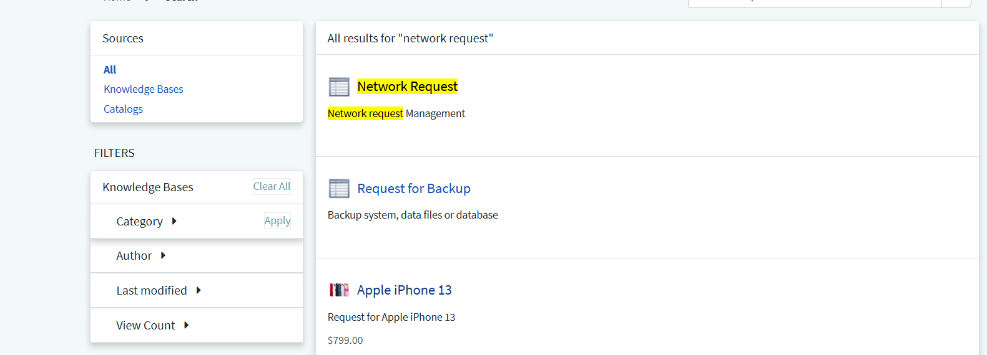
Step 4 – Complete the Request Form
Open the Network Request form.
Enter the required information, including the configured requester, connection, payment, and address details.
Depending on the configuration, requester information may be automatically populated after selecting the relevant user.
Verify that:
- Required fields are completed.
- Appropriate choices are selected.
- Automatically populated fields contain the correct information.
- The entered information is accurate.
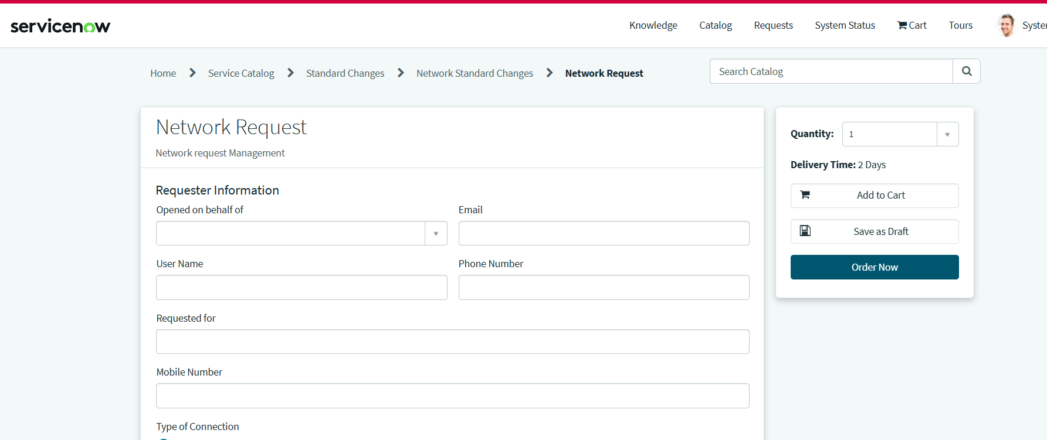
Step 5 – Submit the Request
Click Submit after completing the required information.
ServiceNow processes the submission and generates a new request record.
The newly created request receives a unique request number, which can be used to track the request throughout its lifecycle.
Screenshot Requirement
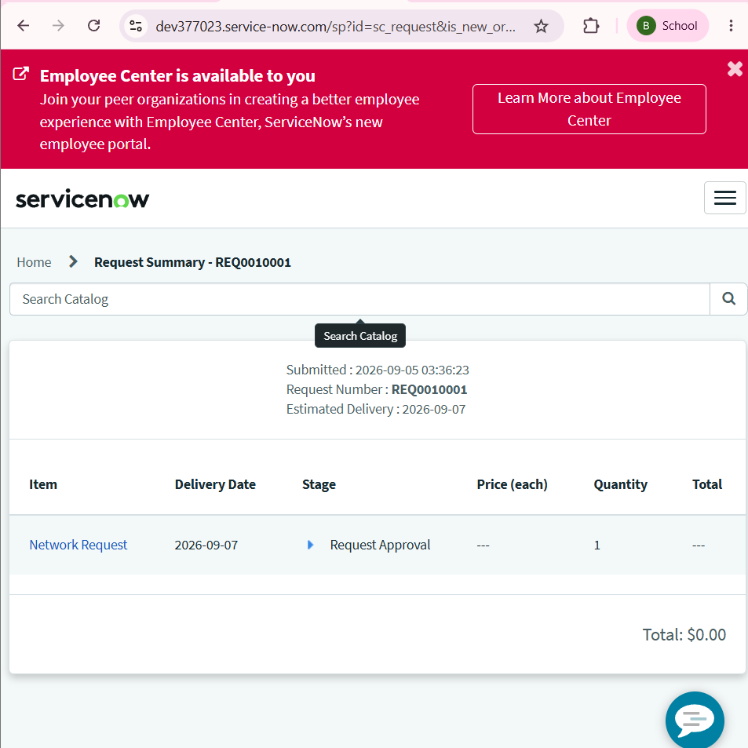
Step 6 – Email Notification
After submission, the configured notification mechanism sends an email to the appropriate recipient(s), depending on the notification configuration.
The notification can provide information such as:
- Request number
- Request status
- Request details
- Submission confirmation
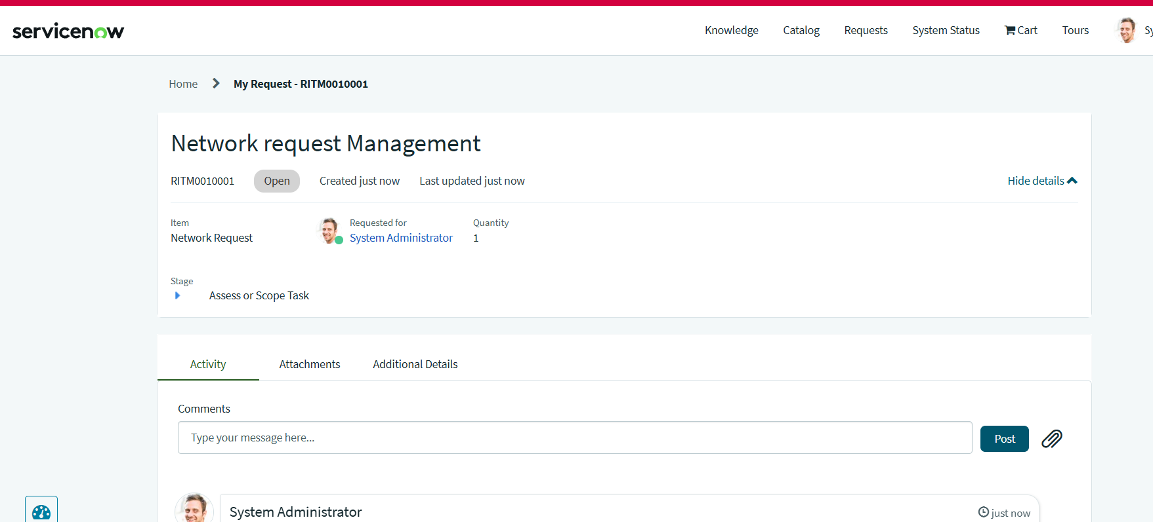
Outcome
The Navigation Flow provides a straightforward end-user journey for submitting a network service request through the ServiceNow Service Portal.
The completed flow ensures that:
User → Service Portal → Network Request → Form Submission → Request Number → Email Notification
This provides a standardized, traceable, and user-friendly request submission experience.
Replicability Note
To reproduce this flow, the user must have access to the configured ServiceNow instance and appropriate permissions to access the Service Portal and Network Request catalog item. The exact portal URL and available services may vary between ServiceNow instances.

